**Gait Analysis-Workflow**

Link-[Gait_analysis](https://colab.research.google.com/drive/1QGqIIYoF95Xf2TJc3ET43a0QH8Pvja7v?usp=sharing)

* Trained CNN model for optical flow merged with cropped average image. Got accuracy of **98.75%**

Link-[cnn_opfl_hsv](https://drive.google.com/file/d/1xKXkajDGRGcqxXRSSftbwEXSoyTwOF5O/view?usp=sharing)

* Trained CNN model for cropped average image. Got accuracy of **70%.**

Link-[cnn_avg_image](https://drive.google.com/file/d/128hM7KWvGmc-DfkpDxRt1irs_7fWyxH5/view?usp=sharing)

* Trained CNN model for optical flow. Got accuracy of **82.5%**.

Link-[cnn_opfl](https://drive.google.com/file/d/1VlZtA2BZROcDoqhOL8nzfYvtJtt9RZSD/view?usp=sharing)

* Sorted the dataset into folders for training the model.
* Found the merged optical flow with cropped average image and saved the result obtained

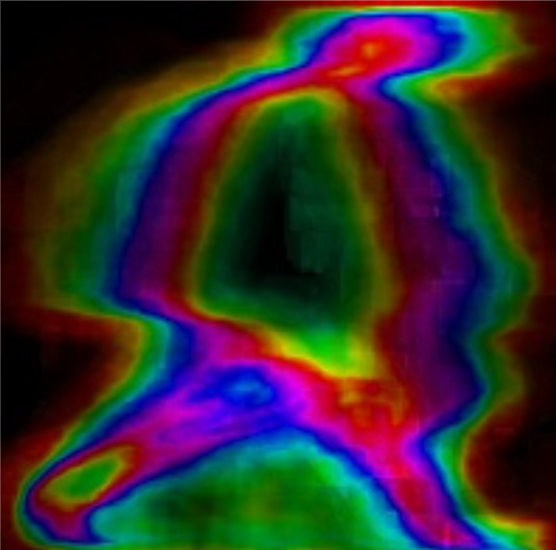

* Trained the ANN model with extracted features. Got accuracy of **94%**

Link-[ann_model](https://drive.google.com/file/d/1T6L6-D8MuSuD6C3Bb7nska7h4SQmlEkR/view?usp=sharing)

* Extracted the features using tsfresh library for the dataset using the time series of head, torso, and leg (x,y) coordinates.
* Found the optical flow of the video both (grayscale and hsv) using cropped (bounding box) images.
* 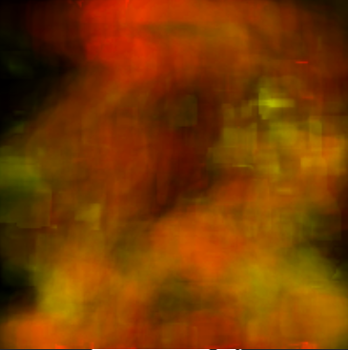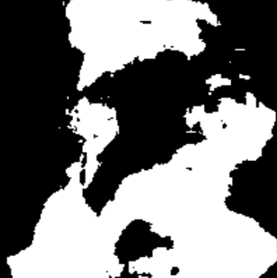
* Found the centroid of each head, torso, and leg image which we will use as coordinates for the time series.
* Cropped the head, torso, and leg of each image for the complete dataset.

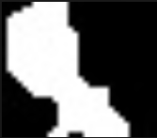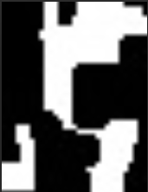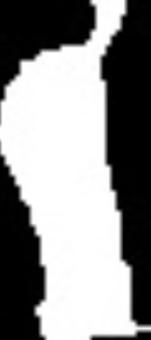

* Computed the average cropped image of the complete video.

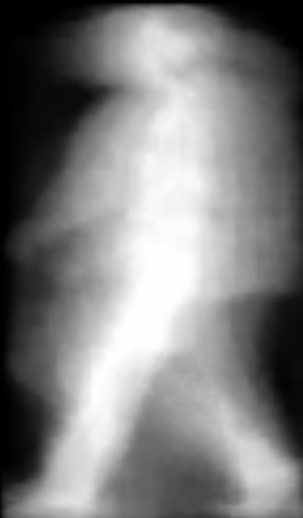

* Computed the average full image of the complete video 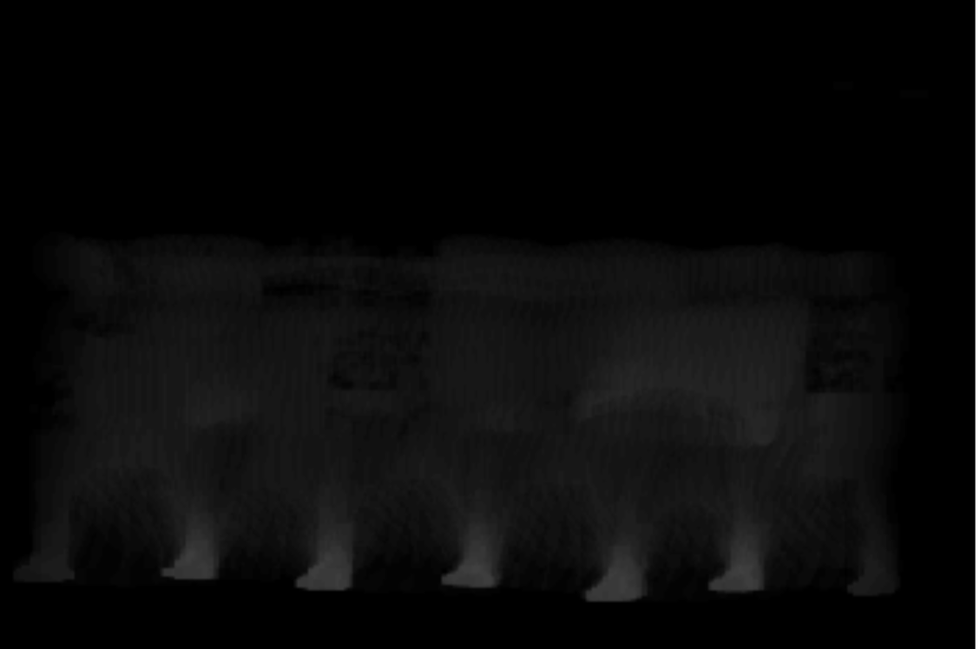
* Cropped the image (bounding box) using the largest contour detection if more than one contours were found.